Self-Referencing Relationships: A Special Case

Self-referencing relationships occur when there is only one table involved. One common example is an Employees table that contains information about the supervisor of each employee. Each supervisor is also an employee and has a supervisor. In this case, there is a one-to-many self-referencing relationship, as each employee has one supervisor, but each supervisor may have more than one employee.

#### **Self-Referencing Relationships**

This particular type of relationship does not exist between a pair of tables, which is why it isn't mentioned at the beginning of this section. It is instead a relationship that exists between the records within a table. Ironically, you'll still regard this throughout the design process as a table relationship.

A table bears a self-referencing relationship (also known as a recursive relationship) to itself when a given record in the table is related to other records within the table. Similar to its dual-table counterpart, a self-referencing relationship can be one-to-one, one-to-many, or many-to-many.

##### **One-to-One**

A self-referencing one-to-one relationship exists when a given record in the table can be related to only one other record within the table. The MEMBERS table in Figure 10.20 is an example of a table with this type of relationship. In this case, a given member can sponsor only one other member within the organization; the SPONSOR ID field stores the member identification number of the member acting as a sponsor. Note that Susan McLain is Tom Wickerath's sponsor.

##### **Figure 10.20. Example of a self-referencing one-to-one relationship.**

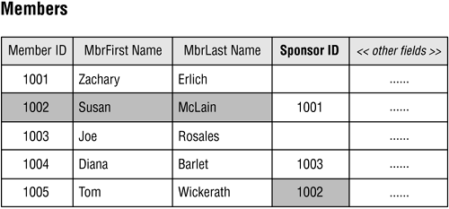

Figure 10.21 shows how you diagram this type of relationship.

##### **Figure 10.21. Diagramming a self-referencing one-to-one relationship.**

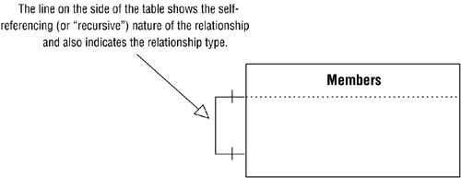

##### **One-to-Many**

A table bears a self-referencing one-to-many relationship to itself when a given record in the table can be related to one or more other records within the table. Figure 10.22 shows an example in which a given customer can refer other customers to the organization. The REFERRED BY field stores the customer identification number of the customer making the referral. Note that Paul Litwin referred both Andy Baron and Mary Chipman.

##### **Figure 10.22. Example of a self-referencing one-to-many relationship.**

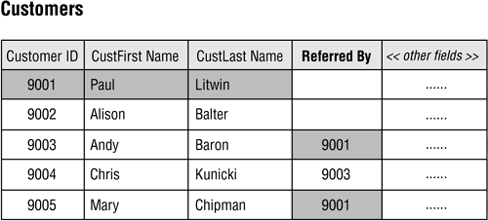

Figure 10.23 shows how you diagram a self-referencing one-to-many relationship.

##### **Figure 10.23. Diagramming a self-referencing one-to-many relationship.**

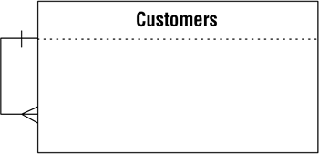

##### **Many-to-Many**

A self-referencing many-to-many relationship exists when a given record in the table can be related to one or more other records within the table and one or more records can themselves be related to the given record. This may sound somewhat confusing at first, but the example in Figure 10.24 should help clarify the matter.

##### **Figure 10.24. Example of a self-referencing many-to-many relationship.**

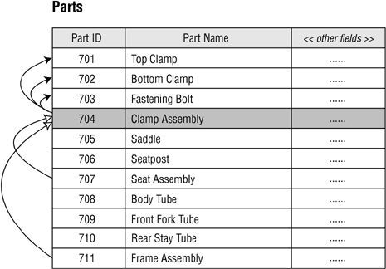

In this case, a particular part can comprise several different component parts, and it can itself be a component of other parts. For example, a clamp assembly (Part ID 704) is composed of a fastening bolt (Part ID 703), a bottom clamp (Part ID 702), and a top clamp (Part ID 701). Additionally, the clamp assembly is itself a component of a seat assembly (Part ID 707) and a frame assembly (Part ID 711). Figure 10.25 shows how you diagram this type of relationship.

##### **Figure 10.25. Diagramming a self-referencing many-to-many relationship.**

